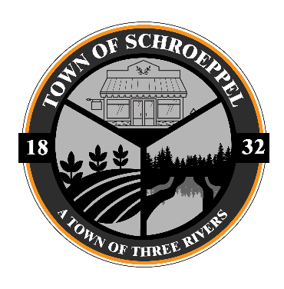
Town of Schroeppel
Planning Board Meeting Minutes
March 25, 2026

Attendees: Don Clark, Chairman, Pete Stancampiano, Lee Goodman, Gordon Walts, Robert Loreman, Leslie Orman, Recording Secretary, Wendy Lougnot, Attorney, CCF

- Meeting to be called to order.

- Pledge of Allegiance.

- Review and approval of meeting minutes from February 25, 2026 Planning Board Meeting.
  - On motion of R. Loreman, seconded by L. Goodman the board unanimously voted to accept the minutes of February 25, 2026.

- Nicole Williams subdivision - Pleasant Lake.
  - Conduct Public Meeting
    - On motion of R. Drumm, seconded by P. Stancampiano the board opened the Public Hearing.
      - The were no discussions offered.
    - On motion of G. Walts, seconded by P. Stancampiano the public meeting was closed.
  - All fees have been paid.
  - Updated drawings provided to address previous Board concerns.
  - Review of application.
    - On motion of P. Stancampiano, seconded by L. Goodman, the Planning Board unanimously resolved to approve the 4-lot subdivision as reflected on the Final Plat entitled “Map of Part of Lot 37 in the 24th Township Scriba’s Patent” prepared by Russell L. Getman, L.L.S. dated November 4, 2024, last revised March 19, 2026 on the condition that (1) the Oswego County Health Department reviews and approves any septic system design and the location of the wells, if required and (2) the provisions of Section 81-16(L)(3) of the Town of Schroeppel Town Code must be complied with for the deeds for all lots in the subdivision
  - SEQR Review.
    - On motion of P. Stancampiano, seconded by R. Drumm the Planning Board unanimously named itself as the Lead Agency of this Unlisted Action and adopted a negative declaration for purposes of SEQR.
  - Subsection (3)(c) provides for the language which must be included in any deed for the lots. We typically require the surveyor to put that requirement/language on the subdivision map also. Was the information added to the document?

- No other new business at this time.

- On motion of P. Stancampiano, seconded by G. Walts the meeting was adjourned.

