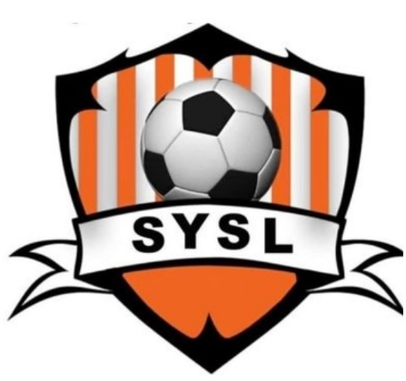

SCHROEPPEL YOUTH SOCCER


Schroeppel Youth Soccer invites players ages 4 -13 to sign up for Summer & Fall Sessions!
The Town of Schroeppel Youth Soccer League announces its 2025 season. Children 4-13 are invited to join. Our sessions will run July 14 –August 13 and September 8 – October 12. All children receive a shirt and a participation award.
Additional volunteer coaches and assistant coaches are always needed.
Registering for one session is $50, both sessions are $90
Sign-ups are currently being held online. Summer deadline to register is June 21, 2025.
For children 4 years old by June 1, 2025 we offer ‘My Buddy and Me’ which incorporates “parent” involvement.. This group will meet once/week: Summer - Monday evening, Fall - Saturday mornings. Both child and “parent” will receive a T-shirt.
U7 is for children ages 5-7. U10 is for children ages 8-10. U13 is for children ages 10-13.
U7, U10, and U13 SUMMER SESSION will practice Monday evening, with games on Wednesday evening.
U7, U10, and U13 FALL SESSION will practice one weekday evening with games on Saturday mornings, Times TBA.
Our new online registration can be found online at https://leagues.bluesombrero.com/schroeppelsoccer.
For more information or questions, call the community services office at 315-695-2801 or email commservice@townofschroeppel.com. We hope to see you and your children for some fun!!

