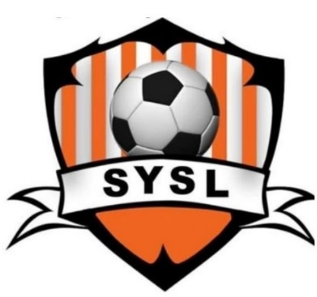
SCHROEPPEL YOUTH SOCCER
Registration begins
April 13, 2026





Schroeppel Youth Soccer invites players ages 4 -13 to sign up for Summer & Fall Sessions!
The Town of Schroeppel Youth Soccer League announces its 2026 season. Children 4-13 are invited to join. Our sessions will run July 13 – August 19 and September 14 – October 17. All children receive a shirt and a participation award.
Additional volunteer coaches and assistant coaches are always needed.
Registering for one session is $50, both sessions are $90.
Sign-ups are currently being held online. Summer deadline to register is June 30, 2026.
$10 Late Fee July 1 – July 8, 2026
For children 4 years old by June 1, 2026, we offer ‘My Buddy and Me’ which incorporates “parent” involvement. This group will meet once/week: Summer - Monday evening, Fall - Saturday mornings. Both child and “parent” will receive a T-shirt.
U7 is for children ages 5-7. U10 is for children ages 8-10. U13 is for children ages 10-13.
U7, U10, and U13 SUMMER SESSION will practice Monday evening, with games on Wednesday evening.
U7, U10, and U13 FALL SESSION will practice one weekday evening with games on Saturday mornings, Times TBA.
Our new online registration can be found online at https://leagues.bluesombrero.com/schroeppelsoccer.
For more information or questions, call the community services office at 315-695-2801 or email commservice@townofschroeppel.com. We hope to see you and your children for some fun!!

