Town of Schroeppel
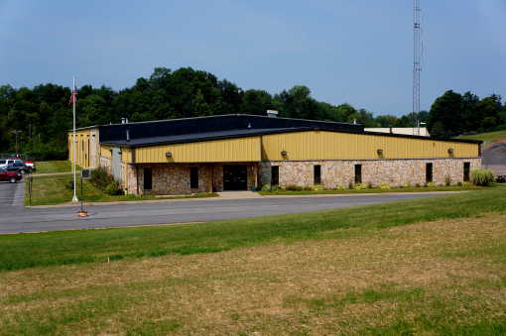
69 County Route 57A, Phoenix, NY 13135
Telephone (315) 695-2801
Fax (315) 695-3231
jnazarian@townofschroeppel.com

TOWN OF SCHROEPPEL
Employment Application

Date ____________________

Position/Title(s) applying for: ______________________________________________________

NAME: ______________________________ SOCIAL SECURITY #: ________________________

ADDRESS ____________________________ HOME # ___________________________

____________________________ CELL # ______________________________

EMAIL ____________________________________

Are you under 18 or over 70 years of age? ________ (Working papers required for individuals 14-17 years old)

If yes, minimum and/or maximum age limits are established for the position for which you are applying, enter your birthdate: ___________

Have you ever been convicted of a felony or a misdemeanor? _________
If yes, please explain: _____________________________________________________________

Are you a Town of Schroeppel resident? _____

Are you under 18 or over 70 years of age? _____
If yes, what is your date of birth? _____

Education:
High School _______________________________________________
Address _______________________________ Graduation Date: ______________
______________________________

College name _____________________________________________
Address _______________________________ Graduation Date: ______________
______________________________
Other Education: __________________________________________________

Work Experience (List last employment first)

Employer ________________________________________ Position ____________________
Address __________________________________ Supervisor’s Name ___________________
__________________________________ Duties ____________________________
Telephone ( ) _____________________ Dates Employed _____________________
Reason for leaving _____________________________________________________________

Employer ________________________________________ Position ____________________
Address __________________________________ Supervisor’s Name ___________________
__________________________________ Duties ____________________________
Telephone ( ) _____________________ Dates Employed _____________________
Reason for leaving _____________________________________________________________

*****************************************************************************

References (Please list three people who are not related to you, but would have adequate knowledge of your character and work habits)

Name ____________________________ Phone # _________________________
Address ___________________________________________________________________
How many years has this person known you? _______

Name ____________________________ Phone # _________________________
Address ___________________________________________________________________
How many years has this person known you? _______

Name ____________________________ Phone # _________________________
Address ___________________________________________________________________
How many years has this person known you? _______

Qualifications: Please specify past experience relating to the position for which you are applying:
______________________________________________________________________________
______________________________________________________________________________
List Specific Interests:
______________________________________________________________________________
______________________________________________________________________________

Please check any of the following certificates that you currently hold and submit copies of certifying cards (if applicable)
______ Red Cross Standard First Aide Expiration Date ____________
______ CPR Expiration Date ____________
Applicant’s statement:
I understand that I may be required to undergo a background check and a search of the NYS Division of Criminal Justices Sex Offender Registry as required by the NYS child Safety Act to determine suitability for appointment. Failure to meet the standards for the background investigation will result in disqualification.
I certify that the answers given herein are true and complete to the best of my knowledge. I authorize investigation of all statements contained in this application for employment as may be necessary in arriving at an employment decision. This application for employment shall be considered active for a period of time not to exceed 6 months.
I hereby understand and acknowledge that, unless otherwise defined by applicable law, any employment relationship with this organization is of an “at will” nature, which means that the Employee may resign at any time and the Employer may discharge Employee at any time with or without cause. It is further understood that this “at will” employment relationship may not be changed by any written document or by conduct unless such change is specifically acknowledged in writing by an authorized executive of this organization.
In the event of employment, I understand that false or misleading information given in my application/interview may result in discharge. I understand also, that I am required to abide by all rules and regulations of the employer.
_______________________________________ __________________
Signature of Applicant Date

