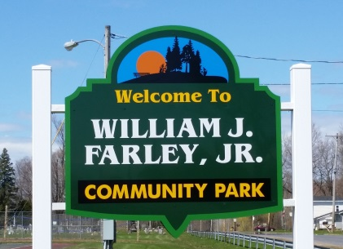
Town of Schroeppel
Office Use Only:
Date Paid: ___________________
Amount Paid: ________________
Cash ________ Check# __________
Online Registration ______________
Res __________ Non Res ________
Late Fee ___________________
Additional Notes
______________________________
Community Services Department
Parks, Recreation, Community Education, Municipal Projects
69 County Route 57A, Phoenix, NY 13135
Telephone (315) 695-2801
Fax (315) 695-3231
hknipp@townofschroeppel.com


Youth: Tuesdays, July 15th – August 12th

Star Set (ages 6 – 8) 5 - 6 PM
Sure Shots (ages 9 – 12) 6 – 7 PM
Aces (ages 13 – 17) 7 - 8 PM

***Registration Form and payment available online at www.townofschroeppel.com ***
Register by June 30th to secure your place!

Youth: $45 Adults: $50

***Registration D***Registration Deadline June 8th*** 8th***

Adults: Thursdays, July 17th – August 14th

Adults (ages 18 and over) 6 – 7 PM

Program Name: 2025 Tennis Lessons Today’s Date: __________
Participants Name: _____________________________ Grade: _____ Age: _____
Address: ____________________________________ Date of Birth: __________
____________________________________ Sex: M _____ F _____
Tennis experience: __________________________________________________________________________
Is the participant a town resident? _______
List any medical conditions or other conditions: ______________________________________
A written doctor’s release is required if you have asthma or health problems. Are there any
physical or health conditions that we need to be aware of? Specify: ____________________

(We cannot guarantee make-ups for weather related cancellations.)

Parent / Guardian Information: (Please list in contact order)
Name: ________________________________________ Relation: _______________________________
Phone Number: _________________________________ Email: ________________________________

Name: ________________________________________ Relation: _______________________________
Phone Number: _________________________________ Email: ________________________________
(over)

Emergency Contact:
Name: ______________________________________________ Relation: ____________________________
Phone Number: ______________________________________
Doctor to notify in case of emergency: _____________________________ Phone: __________________
Hospital preference, if any: __________________________________________________________________

***CONSENT FOR MEDICAL TREATMENT OF A MINOR***
I understand that there is no accident or injury insurance coverage for injuries incurred in this program.
I agree to be financially responsible for any injuries related to program participation.
I understand that the fees for this program are not refundable except in the case of departmental cancellation.
If the participant named above is a minor:
- My signature signifies my permission for this person to participate in this program.
- I give my consent for a licensed physician to perform whatever medical treatment is deemed necessary in my absence.
- I give permission for the above names participant to be transported to the nearest available medical facility in the event of an injury.

_________________________________________________________ ____________________________
Signature of Parent or Guardian OR Adult Participant Date

I give my permission for my child to be photographed for publicity purposes.

Signed: ____________________________________________ Date: _______________________

How did you hear about our program? ________________________________________________________

*Please make checks payable to Town of Schroeppel
Registration forms can be emailed to hknipp@townofschroeppel.com and payment can be made online at https://www.govpaynow.com/gps/user/plc/a001i8. Or registration forms, along with a check or money order, can be dropped off in the Community Services drop box at the front of the Town of Schroeppel office building.
Registrations and payment may also be mailed to:
Community Services Department
Town of Schroeppel
69 County Route 57A
Phoenix, NY 13135

