

2026 OSWEGO COUNTY

RABIES CLINICS

*Suggested donation of $7.00 per pet (cash or check only)

- ALL RABIES CLINICS ARE BY APPOINTMENT ONLY. Appointments will be scheduled clinic by clinic, with lines opening the Wednesday prior
- Clinics are on Wednesday evenings from 6 to 8pm
- All pets must be restrained on a leash or in a pet carrier
- Pets must be at least 3 months old. Pets receiving their first rabies shot must get a booster within 1 year
- Proof of previous vaccination is required to qualify for a 3-year certificate. Accepted forms of proof:
- “Certificate of Vaccination” obtained from veterinarian or Oswego County Environmental Division
- “Dog license” showing rabies expiration date.
*Public Health Law requires all dogs, cats and ferrets be vaccinated against rabies by 4 months old

March 25th
Oswego County DPW Scriba Garage
31 Schaad Drive Oswego

May 6th
Oswego County DPW Pulaski Garage
Centerville Road Pulaski

May 20th
Oswego County DPW Parish Garage
24 Dill Pickle Alley Parish

June 10th
Bristol Hill Transfer Station
3125 State Route 3 Fulton

July 8th
Hannibal Town Highway Garage
68 Cemetery Drive Hannibal

August 5th
West Monroe Town Highway Garage
46 County Route 11 West Monroe

September 16th
Oswego County DPW Pulaski Garage
Centerville Road Pulaski

October 14th
Oswego County DPW Scriba Garage
31 Schaad Drive Oswego

For more information, visit: Oswego County Health Department, 70 Bunner Street Oswego, NY 13126
Phone: 315-349-3564 – Website: www.oswegocountyny.gov – Email: healthdepartment@oswegocountyny.gov
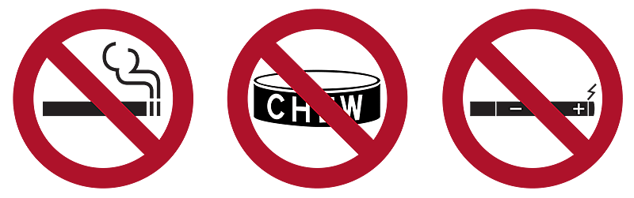
Facebook: Oswego County Health - Instagram: OswegoHealthDpt – CDC: www.cdc.gov/rabies

