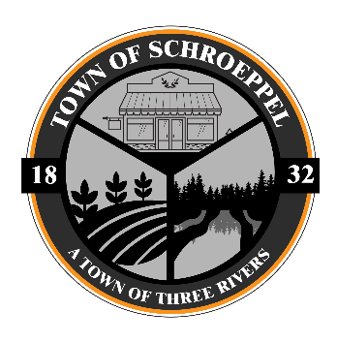
Town of Schroeppel
69 County Route 57A
Phoenix, NY 13135
Phone 695-6231 / Fax 695-1210
Joann Nazarian, Town Supervisor

Seeking Your Voice on Micron Wetland Mitigation
As Town Supervisor, I want to update residents on what Schroeppel has done and how you can get involved regarding the Micron Semiconductor project in nearby Clay.

What We’ve Done So Far:
- Schroeppel has engaged with local, state, and federal representatives, as well as experienced environmental attorneys, to advocate for minimizing wetland impacts and ensuring rigorous mitigation.
- We're closely monitoring the NYS Department of Environmental Conservation (NYSDEC) permitting process, which includes comprehensive wetland mitigation plans proposed for multiple Schroeppel sites. These include:
• Buxton Creek (116.4 acres of wetlands, 8,617 ft of stream mitigation)
• Fish Creek (20 acres wetlands, 5,413 ft stream)
• Oneida River (191.4 acres wetlands)
• Six Mile Creek (44.5 acres wetlands)
• Other sites along Caughdenoy Creek totaling over 118 acres
(More info: https://www.dec.ny.gov/environmental-protection/facilities-in-your-neighborhood/micron )

Public Engagement Opportunity:
The NYSDEC is accepting public comments on these permits through September 1, 2025—via written or oral testimony with equal weight.
(More info: https://www.dec.ny.gov/environmental-protection/facilities-in-your-neighborhood/micron )

How You Can Comment:
- Participate virtually in the NYSDEC hearings on August 12 at 2 p.m. or August 13, 2025 at 6 p.m.
- Submit written comments by mail (postmarked by Sept. 1) or by email (received by 4:45 p.m. on Sept. 1, 2025). Contact details are available on the NYSDEC site.

Why Your Voice Matters:
Your voice is essential in ensuring that the NYSDEC understands the concerns of our residents. Public input can influence the final scope of wetland mitigation and help achieve a more balanced approach—one that protects the environment without compromising Schroeppel’s future development and land use potential.
We encourage all residents to participate in the public comment period and make your concerns known. Together, we can advocate for a smarter, more equitable plan.

